Status of This Document

Version History
Ver. No. | Date | Revised By | Description | Filename
1.0 | March 20, 2006 | Joel Matsumoto | Initial draft for the high level design of house cleaning for Hermes2 | hc high level design v1.0.doc
1.1 | April 6, 2006 | Joel Matsumoto | Added detail for areas of change | Hc high level design v1.1.doc

Table of Contents

1. Status of This Document 2
1.1. Version History 2
2. Table of Contents 3
3. Introduction 4
3.1. Release Information 4
4. House cleaning 5
4.1. General 5
4.2. Html form 5
4.3. Functionality 5
5. Message History Display 6
5.1. General 6
5.2. Functionality 6

Introduction
The document features the high level design of the house cleaning extension for Hermes2.

Release Information

Product Name: | Hermes2 House Cleaning
Version: | 1.0
Product Specification File Name:
Release Specification File Name:
Product Owner:
Technical Owner:

House cleaning

General
The house cleaning options will be added to the core properties page. It will be added to the top to allow the user to access it more conveniently.

Html form
There will be two input elements in the form. One to ask the user if house cleaning is to be activated and the other to send a notification email to a specified address provided by the user. There will be a pair of radio buttons with a simple yes or no to ask if house keeping should be set to on or off. There will also be a text field to allow the user to provide an email address. The email address will be used to send a notification to the user. On top of the afore mentioned elements, there will also be a submit button to update the information in the fields. This will be separate from the current update button belonging to the core properties section.
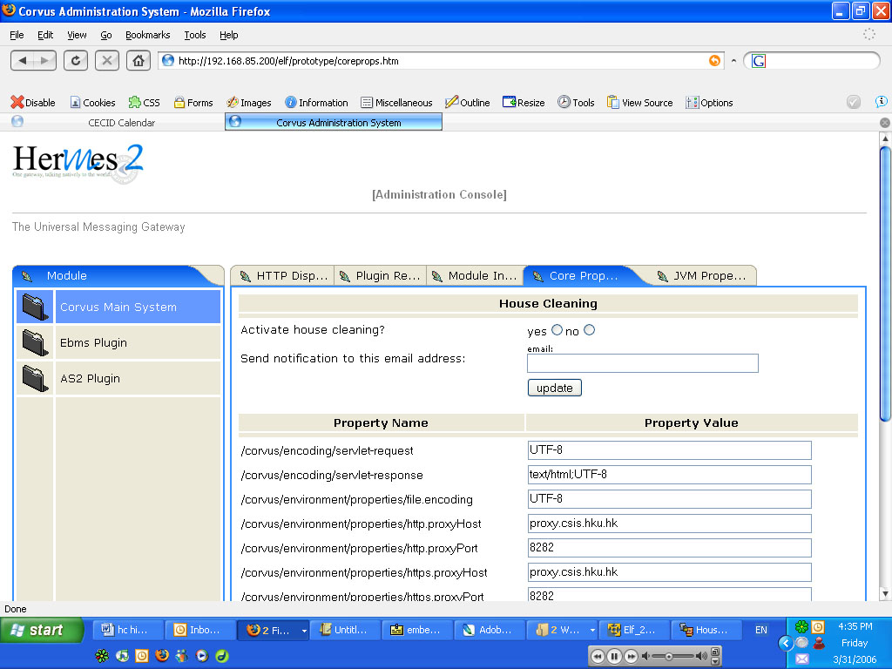

Functionality
In general, once the user fills in the form and clicks on update, the values will be saved to a physical file. It will also display the period of time it will perform the house cleaning.

Scheduler
The scheduler will run in the background and check if housekeeping is enabled. If so, it will proceed to delete all messages in the database that are older than 3 months. It will run once a week, the day is yet to be determined.

Message History Display

General
For both the ebMS and as2 plugin page, there will be one more drop down menu added to allow the user to specify the last 3 months, last 6 months or all messages.
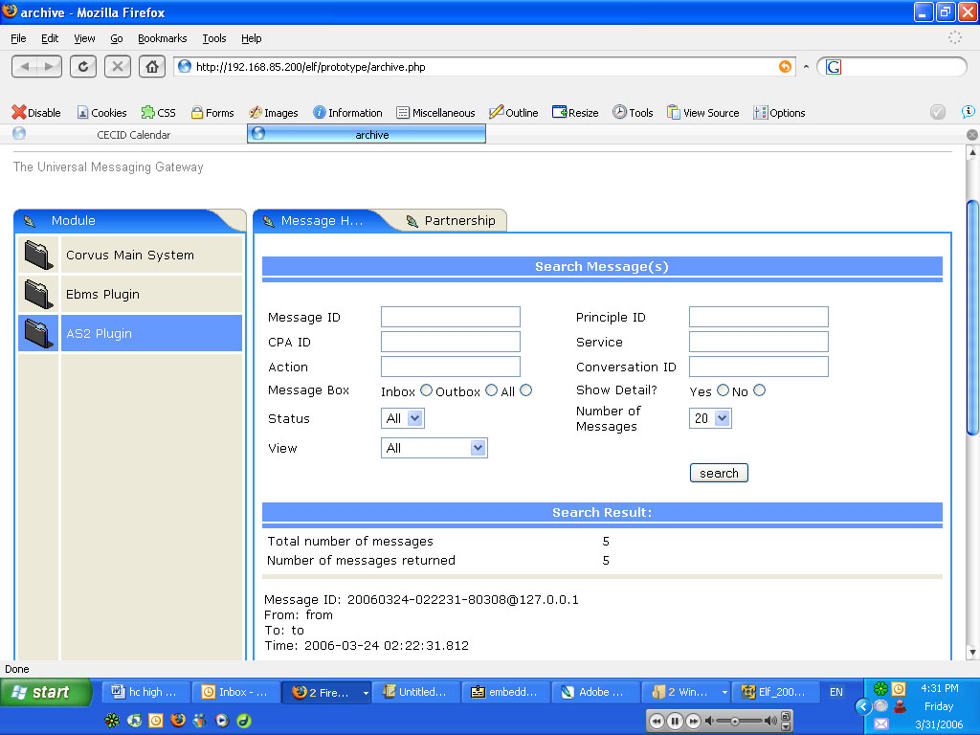

Functionality
Will retrieve the specified messages and display them.

Files of Change

XSL Files
The following files will need to be updated:
properties.xsl (Corvus.Main.Admin.spa.conf.hk.hku.cecid.piazza.corvus.core.main.admin.ui)
Update the layout to add the extra section into the core properties. Also change the header to resemble the other pages. Note: the changes will also affect the JVM tab as they both share the common xsl file.
message_history.xsl
(CorvusAS2.Admin.spa.conf.hk.hku.cecid.edi.as2.admin.ui and CorvusEbMS.Admin.spa.conf.hk.hku.cecid.ebms.admin.ui)
File is located in both the EbMS and AS2 ui folder. Update the layout to include an extra drop down menu.

Config Files
The as2.dao.xml and DAOMessage.xml will need to be changed for both AS2 and EbMS plugins respectively. They are located in the conf folder in the plugins.

Java Files
The following files will need to be updated:
>>Corvus.Main.Admin.src.hk.hku.cecid.piazza.corvus.core.main.admin.listener
PropertiesPageletAdaptor.java
Refactor the code in getCenterSource method.
CorePropertiesPageletAdaptor.java
Add code to load and save the housekeeping options.
>>CorvusAS2.Admin.src.hk.hku.cecid.edi.as2.admin.listener
MessageHistoryPagletAdaptor.java
Add code to include the menu criteria for time.
>>CorvusEbMS.Admin.src.hk.hku.cecid.ebms.admin.listener
MessageHistoryPageletAdaptor.java
Same as above.

New Files
A new properties.xml file will be used to store the house-cleaning data.
A new active task group for the scheduler.
A new class to send email notification.

